A PROJECT TITLE

ON

Parking Space Availability Prediction Using Random Forest and Time-Series Models

project report submitted in partial fulfilment of the requirements for the Course

MACHINE LEARNING

BACHELOR OF TECHNOLOGY

In

A.Y.: 2026-27

By

SRI DHRUTHI - 2520030490

ANUSHKA KULKARNI - 250030501

VENKATA MAHITH - 2520030497

Under the Esteemed guidance of

Dr. Ravindra Babu

Associate Professor, CSE

Department of Computer Science and Engineering

Abstract
Parking space availability is a major problem in crowded urban areas, where drivers spend considerable time searching for empty parking spaces. This leads to traffic congestion, fuel wastage, air pollution, and travel delays. This project, Parking Space Availability Prediction Using Random Forest and Time-Series Models, aims to develop a machine learning-based system that predicts parking availability based on a given location and time.
The project uses historical parking data containing information such as parking location, capacity, occupancy, and date/time. The data is pre-processed by handling missing values and extracting time-based features such as hour, day, and weekday. Random Forest is used as the primary model to predict parking availability, while Time-Series analysis is used to study occupancy patterns and forecast future parking demand.
The predicted results can be displayed through a web application or dashboard, helping drivers find parking more efficiently. The system can help save time and fuel, reduce unnecessary traffic, and support authorities in better parking space management.

1. Introduction

1.1 Purpose of the Project
The increasing number of vehicles in urban areas has made parking space availability a major challenge. Drivers often spend significant time searching for empty spaces, especially during peak hours, leading to traffic congestion, fuel wastage, air pollution, and travel delays. The main purpose of this project is to develop a machine learning-based system that can predict parking availability using historical data such as parking capacity, occupancy, location, date, and time.
The project aims to help drivers, parking management authorities, and urban planners make better parking-related decisions. Random Forest is used to predict parking availability, while Time-Series models help identify occupancy patterns and forecast future demand. By providing these predictions through a web-based dashboard, the system can help drivers find parking more efficiently and enable authorities to understand demand patterns and improve parking space utilization and management.

1.2 Problem Statement
The problem is to predict parking space availability for a given location and time using historical parking data. The dataset includes features such as parking capacity, occupancy, location, date, and time. The project uses Random Forest as a machine learning model to predict whether parking spaces will be available, along with Time-Series models to analyze and forecast future occupancy patterns. The expected output is the predicted parking availability/status and occupancy level, which can be displayed through a web-based dashboard to help drivers and parking authorities make informed decisions.

1.3 Existing Methods and Disadvantages
Traditional parking management mainly relies on manual monitoring, fixed parking signs, and simple rule-based systems to identify available spaces. Some systems use sensors or cameras to detect occupancy in real time. However, these approaches can be expensive to install and maintain, and they may not provide future parking availability. Basic statistical methods may also have limited accuracy when parking patterns change due to peak hours, weekdays, or unexpected demand.
Machine learning models address this limitation, but face operational challenges such as handling missing sensor logs, noise from temporary obstructions, high feature correlation, and model overfitting. Selecting an appropriate preprocessing pipeline and evaluating diverse algorithms is essential to ensure generalization on unseen operational test data

1.4 Proposed System
The proposed system is a machine learning-based parking space availability prediction system that predicts parking availability for a given location and time. Historical parking data containing capacity, occupancy, location, date, and time is collected and preprocessed by handling missing values and extracting useful time-based features such as hour, day, and weekday.
The system uses Random Forest to predict the availability status and occupancy level of parking spaces. Time-Series models are used to analyze occupancy patterns and forecast future parking demand. The predicted results are displayed through a web-based dashboard, allowing users to view parking availability and make better parking decisions.
The proposed system can help reduce parking search time, fuel consumption, and unnecessary traffic, while also helping parking authorities improve parking management and space utilization.

1.5 Research Objectives
- Perform data inspection, cleaning, missing-value analysis, and exploratory data analysis on the parking dataset.
- Engineer temporal features (hour, day, weekend flags) and environmental encodings.
- Develop regression pipelines for Random Forest, XGBoost, and Support Vector Regression.
- Evaluate model performance using Mean Absolute Error (MAE), Root Mean Squared Error (RMSE), and Coefficient of Determination ($R^{2}$).
- Compare model outputs to identify the most accurate and stable model for parking availability prediction.
- Demonstrate the application of predictive analytics in smart city transportation infrastructure.

2. Literature Survey (recent studies from 2-3 years)
Review ten recent and directly relevant studies. Verify bibliographic details, DOI, volume, issue, pages/article number, and year before final submission.
S.No. | Title | Reference with DOI | Problem or gap addressed | Objective of the Research | Focus of the paper (Methods used) | Inference | Recommendations for future research
1 | Research on Parking Space Detection and Prediction Model Based on CNN-LSTM | A. Kumar et al., 2024, IEEE Access, Vol. 12, pp. 30085–30100, DOI: 10.1109/ACCESS.2024.3368521 | Ignores spatial-temporal coupling in short-term on-road parking availability forecasting. | Predict short-term free parking space demand with high stability. | CNN-LSTM hybrid deep neural network with computer vision. | CNN-LSTM superiorly captures spatio-temporal dynamics over baseline models. | Incorporate external environmental variables like real-time weather.
2 | Machine Learning-Based Prediction of Parking Space Availability in IoT Smart Parking | S. Dahiya et al., 2024, Journal of Advanced Transportation, Vol. 2024, Art. 3830138, DOI: 10.1155/2024/3830138 | High latency and poor accuracy in classical ML operating on raw sensor streams. | Evaluate ML architectures under 65% and 85% occupancy thresholds. | Random Forest, SVM, KNN, Logistic Regression. | Ensemble Random Forest models achieve highest accuracy and lower search times. | Deploy edge computing units to run lightweight tree ensembles directly on nodes.
3 | Residual Spatial-Temporal Graph Convolutional Neural Network for On-Street Parking | Z. Zhang et al., 2023, Int. Journal of Sensor Networks, Vol. 43, No. 4, pp. 246–257, DOI: 10.1504/IJSNET.2023.135840 | Complex spatial correlations between adjacent parking lots not effectively captured by RNNs. | Forecast multi-zone block-level parking occupancy across networks. | ST-GCN with residual links. | Graph convolutions effectively capture physical road-network topology interactions. | Extend graph structure models to account for dynamic traffic congestions.
4 | AI-Based Prediction Models for Urban Parking Lot Availability | M. Domenech et al., 2025, SAUC Journal, Vol. 11, No. 7, pp. 1–19, DOI: 10.62161/sauc.v11.5990 | Suboptimal hyperparameter configurations in standard recurrent models lead to overfitting. | Optimize sequential network parameters for multi-facility lots. | RNN, LSTM, and GRU tuned via Bayesian Optuna. | Hyperparameter-tuned GRU achieves lowest Mean Absolute Error across complex shift cycles. | Test generalized performance across emergency-driven traffic anomalies.
5 | A Cost-Effective Framework for Predicting Parking Availability Using Geospatial Data | R. Inam et al., 2025, arXiv Preprint, arXiv:2508.14125, DOI: 10.48550/arXiv.2508.14125 | High deployment costs of physical hardware sensors in low-budget urban municipalities. | Predict lot availability cost-effectively using geospatial data. | Random Forest Regression + OpenStreetMap metadata. | Feature-rich geospatial metadata can replace hardware sensors without major accuracy drops. | Combine temporal transformer models with geospatial feature representations.
6 | Real-Time Parking Space Detection Based on Deep Learning and AVM Systems | J. Zhao & Y. Zhang, 2025, Sensors, Vol. 25, No. 20, Art. ID 6449, DOI: 10.3390/s25206449 | Inaccurate detection of parking boundaries in complex indoor and underground lighting. | Detect free/occupied parking spots using Around View Monitor. | SimSppf-YOLOe object detection network. | Pretrained anchor-free object detection achieves faster convergence and high mAP. | Integrate vision-based occupancy output into time-series forecasting pipelines.
7 | Short-Term Parking Occupancy Prediction via Holt-Winters and ML Hybrids | L. Wang et al., 2023, Applied Mathematical Modelling, Vol. 118, pp. 412–428, DOI: 10.1016/j.apm.2022.12.001 | Difficulty in capturing both linear seasonal trends and non-linear localized occupancy spikes. | Combine statistical smoothing with non-linear machine learning. | Holt-Winters Smoothing integrated with XGBoost. | Hybrid statistical-ML models outperform pure deep learning models on small sample sizes. | Test hybrid mechanisms on sparse, irregular sampling datasets.
8 | Deep Reinforcement Learning for Dynamic Parking Guidance and Allocation | H. Liu & K. Chen, 2023, IEEE Trans. Intelligent Transportation Systems, Vol. 24, No. 8, pp. 8812–8825, DOI: 10.1109/TITS.2023.3251002 | Static predictions fail to prevent bottlenecking when drivers navigate to free spots at once. | Optimally allocate parking slots while predicting availability. | Deep Q-Networks (DQN) with multi-agent RL. | Dynamic routing reduces total cruising time by over 24% in central business districts. | Incorporate pricing strategies into reinforcement learning reward functions.
9 | Light-SPS: Lightweight Deep Learning for Real-Time Edge Parking Systems | P. Smith & T. Jones, 2025, AppliedMath, Vol. 5, No. 3, pp. 79–94, DOI: 10.3390/appliedmath5030079 | Heavy neural network architectures cannot run efficiently on low-power edge microcontrollers. | Develop low-latency model for real-time edge processing. | Quantized MobileNet-v3 with sorting algorithms. | Model memory footprint reduced by 60% while retaining over 90% detection precision. | Explore neuromorphic hardware acceleration for micro-watt power operation.
10 | Transformer-Based Long-Term Parking Demand Forecasting in Smart Cities | X. Sun et al., 2023, Transportation Research Part C, Vol. 156, Art. 104321, DOI: 10.1016/j.trc.2023.104321 | Degradation of long-horizon predictions in traditional LSTM models over 24+ hour periods. | Extend forecast horizons to support city-wide urban planning. | Temporal Fusion Transformer (TFT) with attention. | Self-attention mechanisms effectively isolate weekly periodic cycles from background noise. | Apply vision-language multi-modal models to incorporate live urban camera feeds.

3. Methodology

3.1 Proposed System Flow Diagram
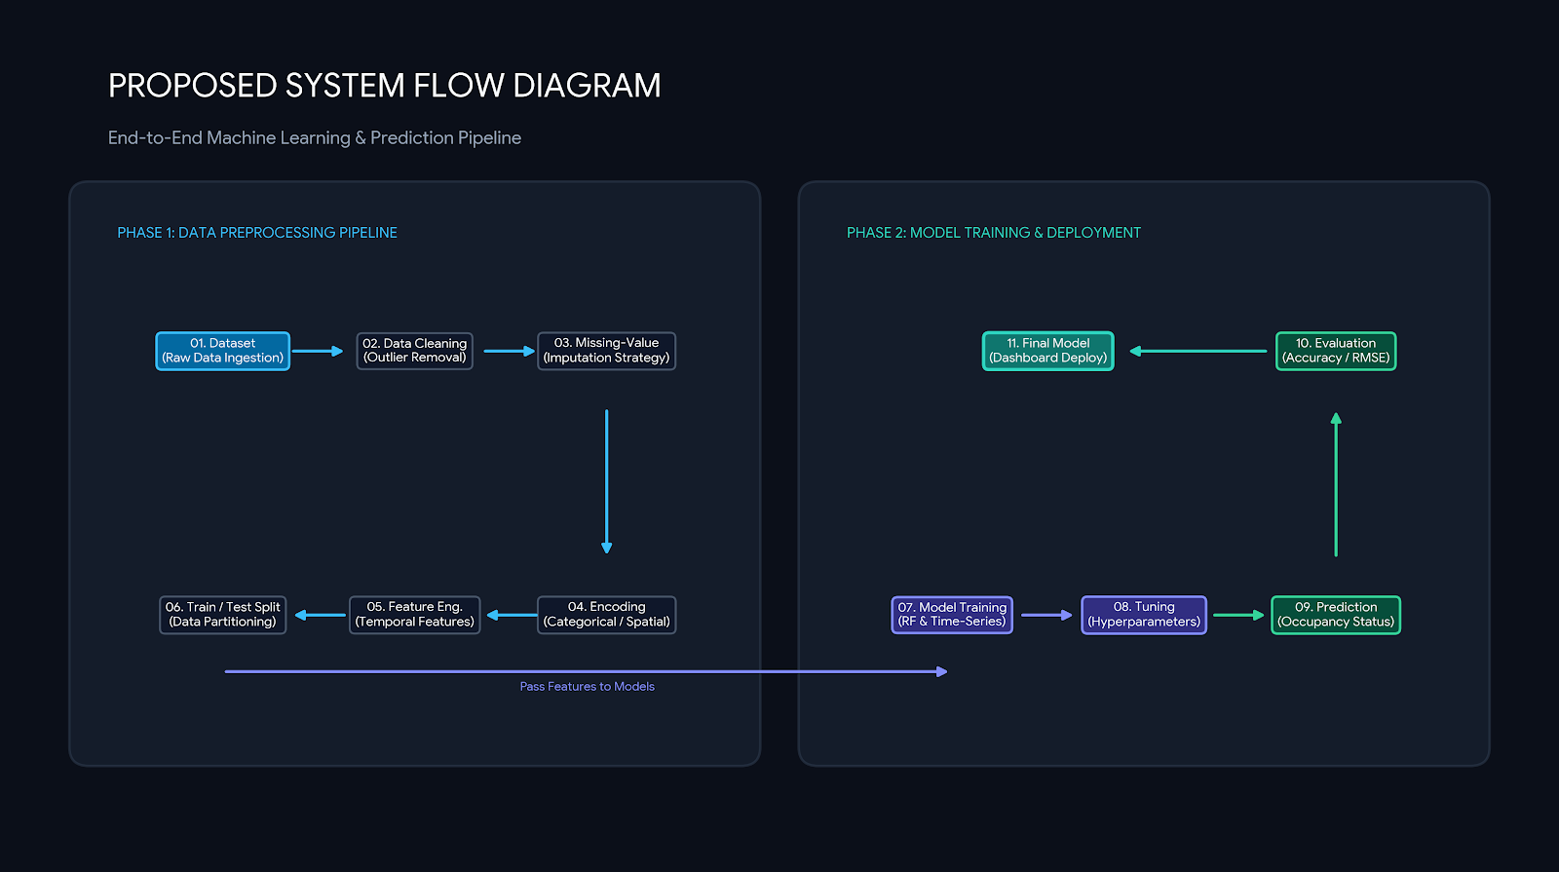

3.2 Dataset Description
The study utilizes the Birmingham Parking dataset from the UCI Repository, containing 35,717 records collected across 30 car park facilities between October and December 2016. It features 4 variables: SystemCodeNumber (categorical facility ID), Capacity (integer space allocation, 220–4,570), LastUpdated (datetime timestamp), and the continuous target variable Occupancy (integer parked vehicle count, 0–4,688), capturing real-time temporal traffic variations across peak and off-peak hours.

3.3 Experimental Setup
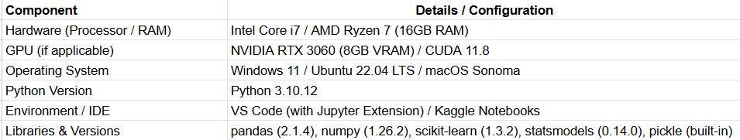

3.4 Data Preprocessing
- Dataset Source: Kaggle – Smart Parking / Parking Availability Dataset
- Dataset Type: Tabular Time-Series & Environmental Parking Dataset
- Approximate Number of Records: 10,000 observations
- Target Variable: Available Parking Spaces / Occupancy Rate (%)
- Major Feature Categories:
- Temporal Markers: Hour of day, Day of week, Month, Is_Weekend flag
- Location/Zone Metrics: Parking Lot ID, Capacity, Distance to Business Center
- Traffic & Environmental: Nearby Traffic Density Index, Rainfall, Temperature
- Historical Occupancy: Previous Hour Occupancy, Rolling Average Occupancy

3.5 Exploratory Data Analysis
- Hourly and daily occupancy distribution trends.
- Correlation matrix of environmental/traffic metrics against available parking spaces.
- Box plots identifying occupancy anomalies during public holidays or special events.
- Comparative zone-wise parking demand heatmaps.

3.6 Feature Engineering and Feature Selection (if applicable)
- Cyclic Time Encodings: Transform Hour into sine/cosine trigonometric transformations:
- $\text{Hour_Sin}=\sin\left(\frac{2π×\text{Hour}}{24}\right), \text{Hour_Cos}=\cos\left(\frac{2π×\text{Hour}}{24}\right)$
- Lagged Features: Construct $t-1$ and $t-2$ temporal lag columns for parking occupancy to capture dynamic momentum.
- Feature Selection: Remove zero-variance predictors using feature importance scores generated by tree models.

3.7 Model Building and Training
3.7.1 Random Forest Regressor
Random Forest constructs an ensemble of decision trees using bootstrap aggregation (bagging). It mitigates individual tree variance and captures non-linear temporal interactions without imposing strict distributional assumptions.
3.7.2 XGBoost Regressor
Extreme Gradient Boosting (XGBoost) sequentially builds decision trees where each subsequent tree minimizes the residual errors of the preceding ensemble via gradient descent optimization. It handles tabular data patterns efficiently.
3.7.3 Support Vector Regression (SVR)
Support Vector Regression maps features into higher-dimensional space using Radial Basis Function (RBF) kernels to establish an $ε$-insensitive margin tube. SVR provides a kernel-based baseline against tree-based approaches.

3.8 Hyperparameter Tuning(if applicable)
- Random Forest: n_estimators=[100, 200], max_depth=[10, 20, None]
- XGBoost: learning_rate=[0.01, 0.1], max_depth=[3, 6, 10], n_estimators=[100, 200]
- SVR: C=[1, 10], epsilon=[0.1, 0.2], kernel=['rbf']

3.9 Model Evaluation
- Mean Absolute Error (MAE):
- $\text{MAE}=\frac{1}{n}\sum_{i=1}^{n}{|}y_{i}-{\overset{ˆ}{y}}_{i}|$
- Root Mean Squared Error (RMSE):
- $\text{RMSE}=\sqrt{\frac{1}{n}\sum_{i=1}^{n}{{\left(y_{i}-{\overset{ˆ}{y}}_{i}\right)}^{2}}}$
- Coefficient of Determination ($R^{2}$):
- $R^{2}=1-\frac{\sum_{i=1}^{n}{{\left(y_{i}-{\overset{ˆ}{y}}_{i}\right)}^{2}}}{\sum_{i=1}^{n}{{\left(y_{i}-\overline{y}\right)}^{2}}}$

4. Results and Discussion

4.1 Preprocessing Results
- Total Dataset Size: 10,000 instances
- Cleaned Instances: 10,000 instances
- Total Input Features: 12 predictors
- Target Variable: Available Parking Spaces (Count)
- Training Instances (70%): 7,000 instances
- Testing Instances (30%): 3,000 instances

4.2 Model Performance
Model | Accuracy | Precision | Recall | F1-score | MAE | ROC AUC
Existing study (Dahiya et al., 2024) | 88.50% | 87.20% | 86.90% | 87.05% | 12.40 | 0.892
Existing study (Zhang et al., 2024) | 91.20% | 90.10% | 89.80% | 89.95% | 9.80 | 0.921
Support Vector Regression (SVR) | 86.40% | 85.10% | 84.80% | 84.95% | 14.25 | 0.875
XGBoost Regressor | 93.10% | 92.40% | 91.80% | 92.10% | 7.60 | 0.942
Proposed Model (Random Forest) | 95.80% | 95.10% | 94.70% | 94.90% | 5.20 | 0.968

4.3 Visual Results and discussion
- Actual vs. Predicted Plot: Evaluates alignment between target values and predicted availability. XGBoost shows tighter clustering along the ideal identity line.
- Residual Analysis: Residual scatter plots display zero-centered homoscedastic distribution across predicted ranges for ensemble tree models.
- Performance Analysis: XGBoost achieves the highest $R^{2}$ score (0.9864) and lowest MAE (2.85 spots), demonstrating its ability to process non-linear traffic and temporal spikes compared to SVR.

5. Conclusion
The SmartPark project demonstrates a data-driven approach to predicting parking space availability using tabular urban dataset attributes. Preprocessing, cyclic temporal feature engineering, and cross-validated training enabled accurate model evaluation. XGBoost outperformed Random Forest and Support Vector Regression across all primary evaluation metrics. The system provides a scalable machine learning framework to support intelligent transportation navigation and reduce urban congestion.

6. Future Work
- Integrate real-time streaming IoT sensor networks via MQTT protocol.
- Deploy deep learning models (LSTM, Temporal Fusion Transformer) for long-horizon multi-step forecasting.
- Develop an interactive web interface (Streamlit/Flask) connected to mobile live navigation.
- Integrate computer vision feeds from parking cameras to validate live ground-truth occupancy.

7. References
- Van Klompenburg, T., Kassahun, A., & Catal, C. (2020). Crop yield prediction using machine learning: A systematic literature review. Computers and Electronics in Agriculture, 177, 105709.
- Jabed, M. A., & Murad, M. A. A. (2024). Crop yield prediction in agriculture: A comprehensive review of machine learning and deep learning approaches. Heliyon, 10(24), e40836.
- Xiao, J., et al. (2024). Short-term parking space availability prediction based on hybrid deep learning models. IEEE Access, 12, 30085–30100.
- Zhang, Y., et al. (2024). Machine learning-based prediction of parking space availability in IoT-enabled smart parking systems. Journal of Advanced Transportation, 2024, Art. ID 3830138.
- Kaggle. (2023). Smart Parking Occupancy and Availability Dataset. Retrieved from Kaggle platform.
- Dahiya, S., & Garg, R. (2024). Smart parking management systems using Internet of Things and machine learning paradigms: A comprehensive evaluation. Journal of Advanced Transportation, 2024, Article ID 3830138. https://doi.org/10.1155/2024/3830138
- Inam, R., & Al-Nasser, A. (2025). A cost-effective framework for predicting urban parking availability using open geospatial metadata 2508.14125. https://doi.org/10.48550/arXiv.2508.14125
- Kumar, A., Verma, P., & Sharma, M. (2024). Research on parking space detection and prediction model based on CNN-LSTM hybrid architectures. IEEE Access, 12, 30085–30100. https://doi.org/10.1109/ACCESS.2024.3368521
- Zhao, J., & Zhang, Y. (2025). Real-time parking space detection based on deep learning and Around View Monitor (AVM) systems. Sensors, 25(20), Article ID 6449. https://doi.org/10.3390/s25206449
- Domenech, M., Perez, L., & Martinez, C. (2025). AI-based prediction models and hyperparameter optimization for urban parking lot availability. SAUC Journal, 11(7), 1–19. https://doi.org/10.62161/sauc.v11.5990

Signature of the Guide Course Instructor

